Supplement 2
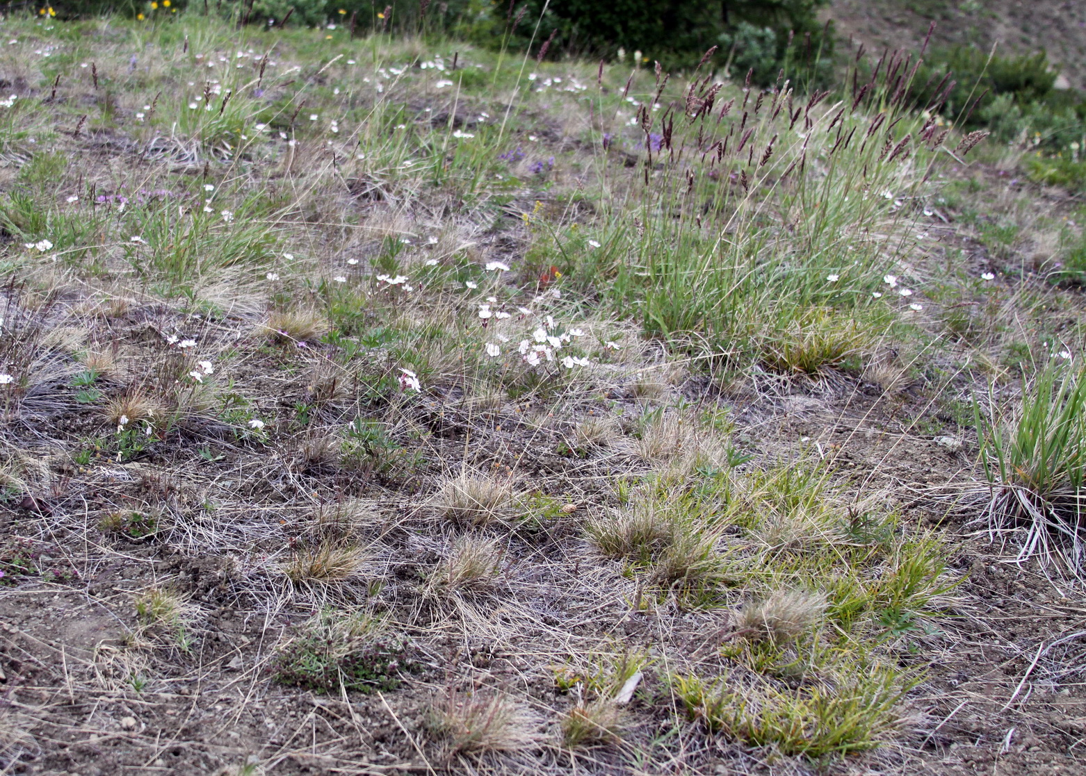

Petrophytic stepoids. The vegetation is represented by sparse (total projective cover (TPC) 20-60%) grass-forb and forb-sedge communities. The total projective cover depends on the weather conditions of the growing season. The flora includes almost 70 species of vascular plants. The most common are grasses (Calamagrostis purpurascens R. Br., Festuca kolymensis Drobov) and sedge Carex pediformis C.A. Mey. Fescue and sedges dominate during hot, dry summers; grasses takes first place in wetter years. Other types of grasses are less abundant: Festuca jacutica Drobov, Poa attenuata Trin., Bromus pumpellianus Scribn.. Of the steppe sedges, the less widespread is Carex duriuscula C. A. Mey., and C. rupestris All.. The flora of petrophytic stepoids is represented by a rich variety of herbs, among which the most common are Pulsatilla multifida (G. Pritz.) Juz., Potentilla arenosa (Turcz.) Juz., Phlox sibirica L., Silene stenophylla Ledeb., Pedicularis venusta Schang. ex Bunge, Dracocephalum palmatum Stephan., Arnica iintermedia Turcz., Arenaria tschuktschorum Regel, Dianthus versicolor Fisch. ex Link., Thymus diversifolius Klok., Veronica incana L., Galium verum L., Myosotis asiatica (Vestergren) Schischkin et Serg. Also in the petrophytic cenosis there are sagebrushes: Artemisia tilesii Ledeb., less commonly A. dracunculus L., and A. borealis Pall. Spots of crowberry Empetrum androgynum V.N. Vassil., fireweed Chamaenerion angustifolium (L.) Scop., Siberian lettuce Lactuca sibirica (L.) Maxim., tansy Tanacetum vulgare L., cowberry Vaccinium vitis-idaea L., as well as a single undergrowth of shrubs of rosehip Rosa acicularis Lindl., and dwarf pine Pinus pumila (Pall.) Regel. are represented on the periphery of petrophytic phytocenoses.

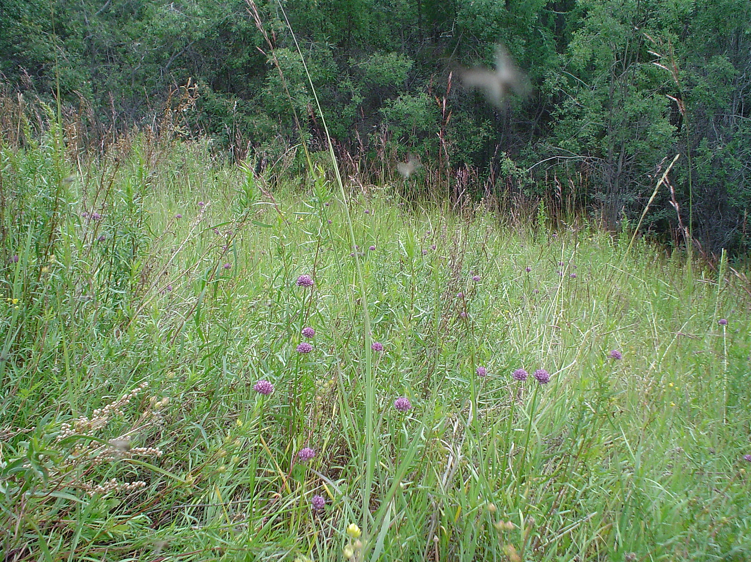

Thermophytic stepoids. The vegetation is represented by sagebrush-forb-grass and sagebrush-grass communities with a total projective cover (TPC) of 50-90%. The flora is less diverse, although it has some species in common with petrophytic stepoids. Dominant species: Artemisia dracunculus L. and Poa attenuata Trin. In especially warm years, co-dominance with other grasses is possible: Calamagrostis purpurascens R. Br., Bromus pumpellianus Scribn., Elymus jacutensis (Drob.) Tzvelev), less often Elytrigia jacutorum (Nevski) Nevski. Forbs are quite abundant; they are dominated by Pulsatilla multifida (G. Pritz.) Juz., Potentilla tanacetifolia Willd., Veronica incana L. Other herbs are rarer and grow unevenly: Allium strictum Schrad., Silene repens Patrin., Thymus diversifolius Klok., Galium boreale L., Myosotis asiatica (Vestergren) Schischkin et Serg., Astragalus ishigensis Maxim. ex Com.. Fireweed Chamaenerion angustifolium (L.) Scop., Siberian lettuce Lactuca sibirica (L.) Maxim., tansy Tanacetum vulgare L., arnica Arnica intermedia Turcz., cowberry Vaccinium vitis-idaea L., etc., and also isolated rosehip shrubs Rosa acicularis Lind., and dwarf pine Pinus pumila (Pall.) Regel. are represented on the periphery of thermophytic phytocenoses.

