Supplements
Figures

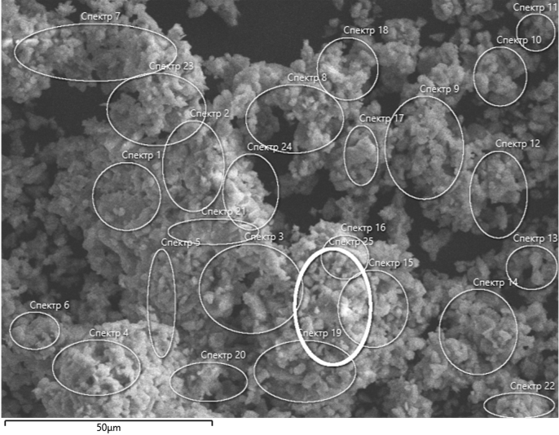
Fig. S1. Image of the areas for determining the composition of the LaMgAl₁₁O₁₉ sample
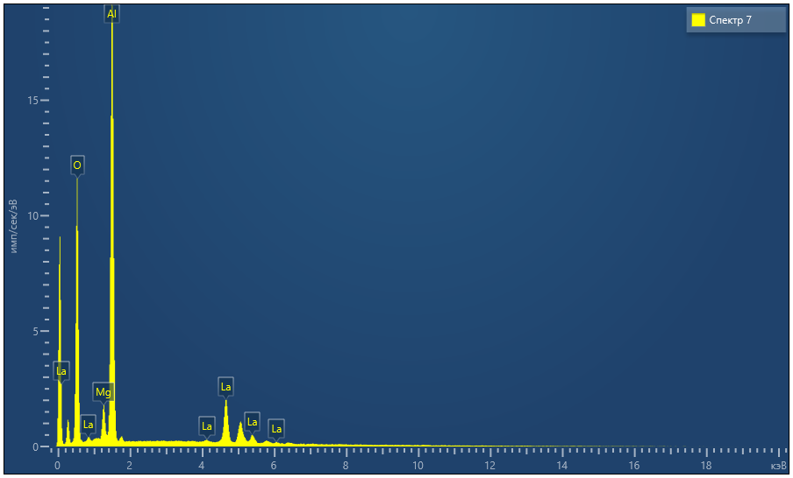
Fig. S2. EDX spectrum of LaMgAl₁₁O₁₉ sample
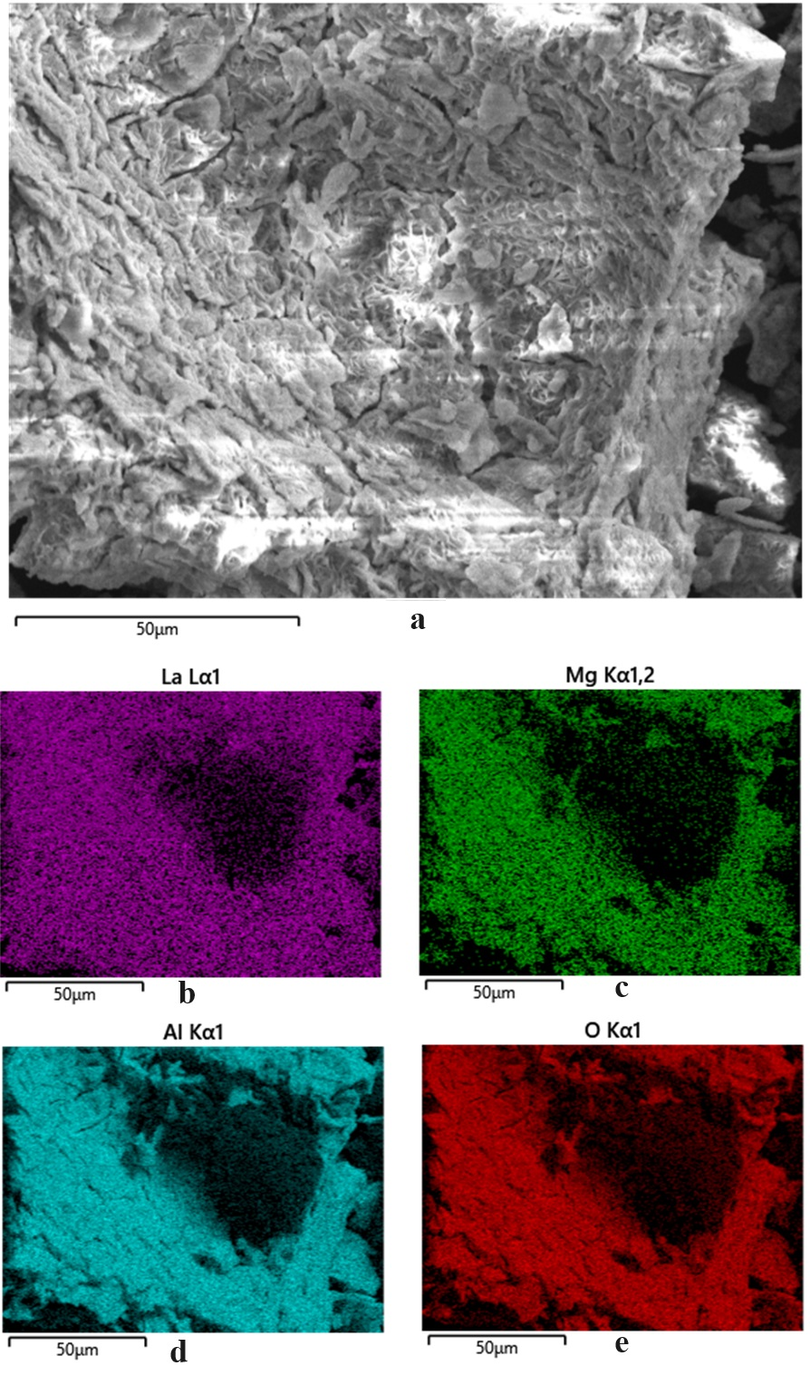
Fig. S3a-e. Mapping the distribution of elements on the surface of the LaMgAl₁₁O₁₉ sample.
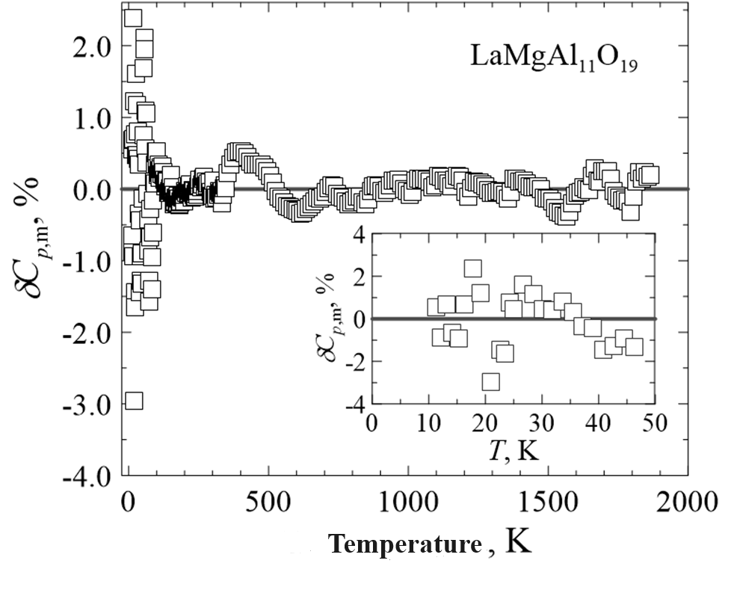
Fig. S4. Relative deviations (δC_{p,m}, %) of the experimental values of the heat capacity of LaMgAl₁₁O₁₉ from the smoothing curve.
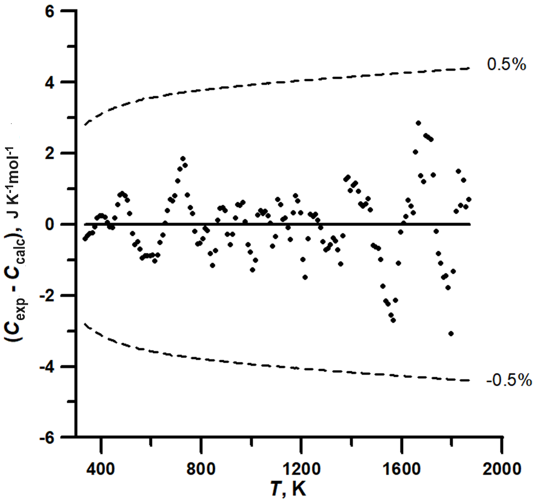
Fig. S5. Scattering of experimental values of the heat capacity of LaMgAl₁₁O₁₉ on the smoothed dependence calculated using equation (3).
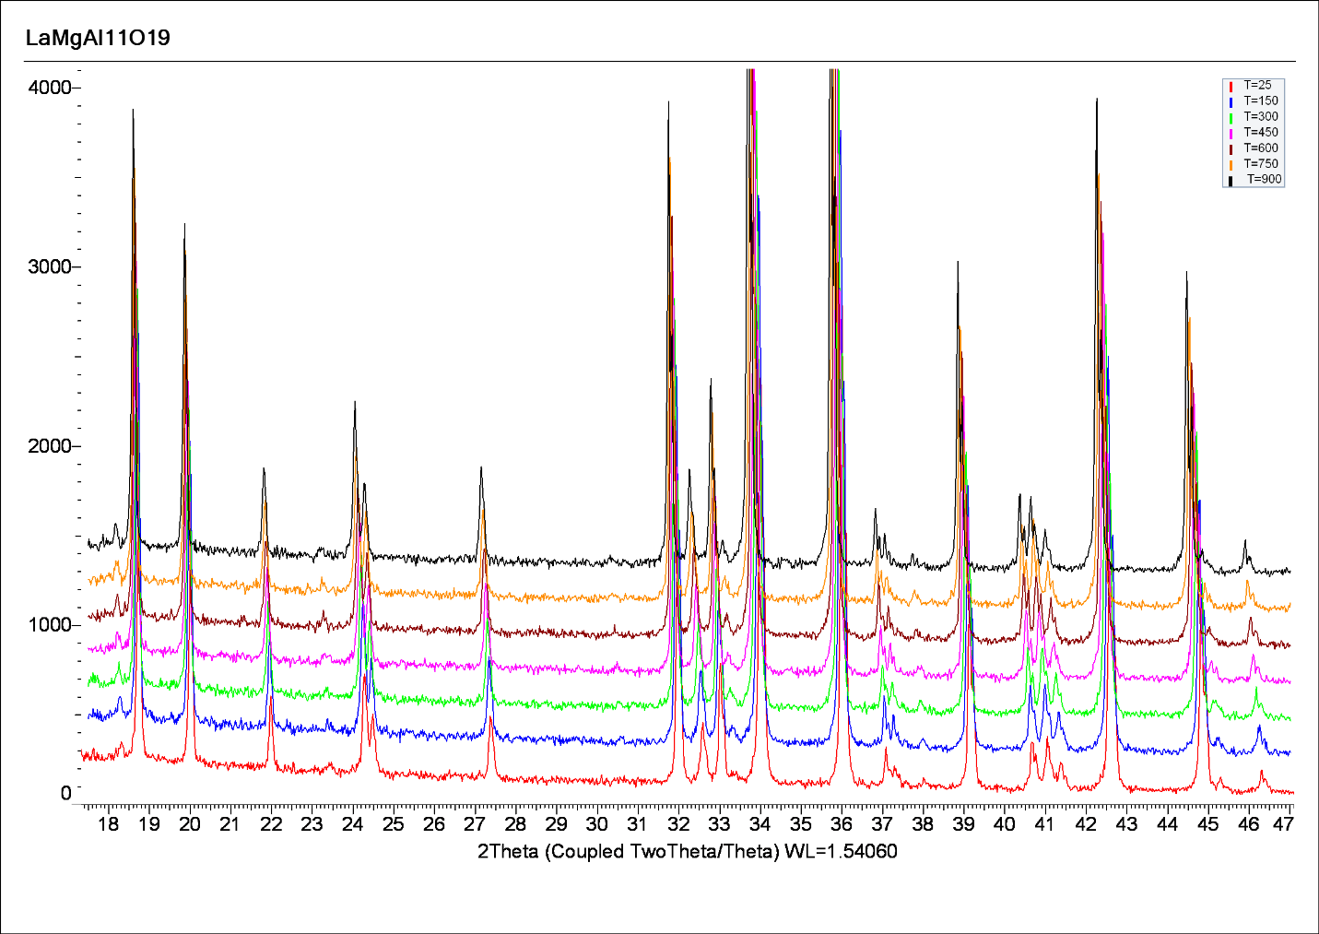
Fig. S6. X-ray diffraction patterns of the LaMgAl₁₁O₁₉ sample obtained at temperatures of 298 K, 423 K, 573 K, 723 K, 873 K and 1173 K.

Tables

Table S1. Heat capacity of LaMgAl₁₁O₁₉ in J K⁻¹mol⁻¹ according to relaxation calorimetry (MW = 763.998 g mol-1).
T, K | C_{p} | T, K | C_{p} | T, K | C_{p}
7.28 | 0.1212 | 10.43 | 0.3560 | 16.35 | 1.373
7.29 | 0.1215 | 10.44 | 0.3574 | 16.36 | 1.376
7.29 | 0.1218 | 10.46 | 0.3594 | 16.49 | 1.409
7.73 | 0.1450 | 11.25 | 0.4470 | 17.66 | 1.729
7.73 | 0.1453 | 11.27 | 0.4496 | 17.82 | 1.776
7.74 | 0.1455 | 11.30 | 0.4528 | 17.99 | 1.827
7.84 | 0.1514 | 12.14 | 0.5614 | 19.07 | 2.177
7.84 | 0.1516 | 12.16 | 0.5643 | 19.21 | 2.227
7.85 | 0.1521 | 12.19 | 0.5685 | 19.42 | 2.301
8.34 | 0.1821 | 13.20 | 0.7228 | 20.66 | 2.768
8.34 | 0.1824 | 13.26 | 0.7318 | 20.94 | 2.884
8.35 | 0.1826 | 13.33 | 0.7437 | 20.96 | 2.892
8.97 | 0.2265 | 14.13 | 0.8867 | 22.43 | 3.542
8.99 | 0.2285 | 14.23 | 0.9041 | 22.59 | 3.622
9.00 | 0.2290 | 14.30 | 0.9191 | 22.59 | 3.623
9.67 | 0.2842 | 15.22 | 1.108 | 24.24 | 4.475
9.68 | 0.2853 | 15.29 | 1.123 | 24.36 | 4.541
9.70 | 0.2863 | 15.39 | 1.144 | 24.38 | 4.551

Table S2. Heat capacity of LaMgAl₁₁O₁₉ in J K⁻¹mol⁻¹ according to adiabatic calorimetry (MW = 763.998 g mol⁻¹).
T, K | C_{p} | T, K | C_{p} | T, K | C_{p}
23.40 | 3.999 | 77.31 | 69.35 | 187.63 | 326.2
23.99 | 4.392 | 78.56 | 69.94 | 189.57 | 330.4
24.97 | 5.013 | 78.56 | 71.40 | 191.50 | 334.6
25.55 | 5.412 | 79.19 | 72.70 | 193.44 | 338.8
26.69 | 6.194 | 80.56 | 73.75 | 195.37 | 343.0
27.28 | 6.593 | 81.13 | 76.49 | 197.31 | 346.9
28.40 | 7.378 | 82.49 | 77.76 | 199.24 | 351.4
28.99 | 7.774 | 84.42 | 81.80 | 201.14 | 355.5
30.13 | 8.635 | 86.36 | 85.87 | 203.07 | 359.6
30.72 | 9.092 | 88.30 | 90.14 | 204.99 | 363.5
31.87 | 10.04 | 90.24 | 94.37 | 206.91 | 367.6
32.47 | 10.59 | 92.18 | 98.40 | 208.84 | 371.7
33.63 | 11.59 | 94.13 | 102.8 | 210.76 | 375.4
34.24 | 12.10 | 96.07 | 107.2 | 212.68 | 379.1
35.40 | 13.13 | 98.02 | 111.5 | 214.60 | 382.9
36.01 | 13.57 | 99.97 | 115.7 | 216.52 | 387.1
37.19 | 14.72 | 101.91 | 120.4 | 218.44 | 390.5
37.80 | 15.32 | 103.87 | 124.4 | 220.35 | 394.6
38.98 | 16.48 | 105.82 | 129.0 | 222.27 | 397.8
39.60 | 17.11 | 107.77 | 133.8 | 224.18 | 401.2
40.79 | 18.15 | 109.72 | 138.3 | 226.09 | 405.1
41.41 | 18.90 | 111.67 | 142.8 | 228.00 | 408.8
42.61 | 20.09 | 113.62 | 147.7 | 229.92 | 412.2
43.23 | 20.94 | 115.57 | 152.5 | 231.82 | 415.6
44.44 | 22.17 | 117.52 | 157.1 | 233.73 | 419.3
45.07 | 22.86 | 119.48 | 162.0 | 235.64 | 422.4
46.28 | 24.15 | 121.43 | 167.0 | 237.54 | 425.8
46.91 | 24.95 | 123.39 | 171.6 | 239.44 | 429.3
48.13 | 26.41 | 125.34 | 176.6 | 241.34 | 432.8
48.77 | 27.31 | 127.29 | 181.3 | 243.24 | 436.0
49.99 | 28.85 | 129.25 | 186.0 | 245.14 | 439.1
50.63 | 29.89 | 131.20 | 190.9 | 247.03 | 442.5
51.85 | 31.43 | 133.16 | 195.9 | 248.93 | 446.1
52.50 | 32.48 | 135.11 | 200.8 | 250.82 | 449.3
53.73 | 34.16 | 137.07 | 205.7 | 253.68 | 454.3
54.38 | 35.09 | 139.02 | 210.6 | 257.56 | 460.1
55.62 | 36.81 | 140.98 | 215.1 | 261.41 | 466.4
56.28 | 37.76 | 142.93 | 220.0 | 265.26 | 472.8
57.52 | 39.35 | 144.88 | 224.9 | 269.09 | 478.8
58.16 | 39.93 | 146.83 | 229.9 | 272.93 | 483.9
59.41 | 41.63 | 148.79 | 234.7 | 276.75 | 489.8
60.04 | 42.34 | 150.74 | 239.5 | 280.56 | 495.0
61.30 | 44.08 | 152.67 | 244.7 | 284.38 | 500.5
61.92 | 45.19 | 154.61 | 249.0 | 288.20 | 505.8
63.19 | 47.04 | 156.56 | 253.7 | 292.00 | 510.3
63.80 | 47.63 | 158.51 | 258.6 | 295.79 | 515.1
65.07 | 49.54 | 160.45 | 263.1 | 299.58 | 519.9
65.69 | 50.39 | 162.40 | 267.4 | 303.26 | 525.7
66.96 | 52.17 | 164.34 | 272.1 | 307.02 | 529.1
67.58 | 53.17 | 166.29 | 276.8 | 310.77 | 533.9
68.85 | 54.93 | 168.23 | 281.6 | 314.52 | 538.1
69.47 | 55.72 | 170.17 | 286.1 | 318.26 | 542.7
70.75 | 57.70 | 172.12 | 290.5 | 322.00 | 547.3
71.52 | 58.30 | 174.06 | 295.0 | 325.73 | 551.4
72.80 | 60.621 | 176.00 | 299.8 | 329.45 | 555.5
73.42 | 61.471 | 177.94 | 304.2 | 333.16 | 559.6
74.71 | 63.98 | 179.88 | 308.3 | 336.87 | 563.2
75.34 | 65.06 | 181.82 | 312.77 | 340.57 | 567.6
76.63 | 67.70 | 183.76 | 317.24 | 344.26 | 571.5
77.27 | 68.89 | 185.70 | 321.6 | 347.93 | 575.0

Table S3. Heat capacity of LaMgAl₁₁O₁₉ in J K⁻¹mol⁻¹ according to differential scanning calorimetry (MW = 763.998 g mol⁻¹).
T, K | C_{p} | T, K | C_{p} | T, K | C_{p}
315 | 539.2 | 835 | 761.8 | 1355 | 826.6
325 | 550.6 | 845 | 763.1 | 1365 | 828.5
335 | 560.6 | 855 | 765.1 | 1375 | 831.1
345 | 572.3 | 865 | 767.5 | 1385 | 832.2
355 | 583.0 | 875 | 769.3 | 1395 | 832.9
365 | 592.9 | 885 | 770.9 | 1405 | 834.1
375 | 602.3 | 895 | 772.3 | 1415 | 835.2
385 | 611.1 | 905 | 773.1 | 1425 | 836.0
395 | 619.1 | 915 | 774.2 | 1435 | 836.7
405 | 626.6 | 925 | 776.0 | 1445 | 837.7
415 | 633.5 | 935 | 777.8 | 1455 | 838.8
425 | 639.9 | 945 | 779.6 | 1465 | 839.9
435 | 646.0 | 955 | 781.0 | 1475 | 840.7
445 | 651.8 | 965 | 782.4 | 1485 | 840.7
455 | 657.6 | 975 | 783.2 | 1495 | 841.7
465 | 663.2 | 985 | 783.9 | 1505 | 842.6
475 | 668.4 | 995 | 785.1 | 1515 | 843.3
485 | 673.1 | 1005 | 785.9 | 1525 | 843.6
495 | 677.5 | 1015 | 787.4 | 1535 | 844.2
505 | 681.6 | 1025 | 790.0 | 1545 | 845.1
515 | 685.3 | 1035 | 791.4 | 1555 | 845.8
525 | 688.6 | 1045 | 792.6 | 1565 | 846.7
535 | 692.0 | 1055 | 793.9 | 1575 | 848.2
545 | 695.7 | 1065 | 795.0 | 1585 | 850.3
555 | 698.9 | 1075 | 796.0 | 1595 | 852.1
565 | 701.9 | 1085 | 796.6 | 1605 | 853.4
575 | 705.2 | 1095 | 798.1 | 1615 | 854.6
585 | 708.2 | 1105 | 800.4 | 1625 | 856.0
595 | 711.1 | 1115 | 801.4 | 1635 | 856.8
605 | 714.0 | 1125 | 802.2 | 1645 | 857.6
615 | 716.6 | 1135 | 803.4 | 1655 | 860.3
625 | 719.4 | 1145 | 804.3 | 1665 | 862.1
635 | 722.3 | 1155 | 805.2 | 1675 | 861.6
645 | 725.0 | 1165 | 807.1 | 1685 | 862.5
655 | 727.8 | 1175 | 808.7 | 1695 | 864.7
665 | 730.5 | 1185 | 809.7 | 1705 | 865.7
675 | 733.1 | 1195 | 810.5 | 1715 | 866.6
685 | 735.3 | 1205 | 810.3 | 1725 | 866.6
695 | 737.6 | 1215 | 811.0 | 1735 | 865.9
705 | 740.1 | 1225 | 813.2 | 1745 | 866.3
715 | 742.5 | 1235 | 815.0 | 1755 | 867.0
725 | 744.8 | 1245 | 816.0 | 1765 | 867.6
735 | 746.6 | 1255 | 817.2 | 1775 | 868.6
745 | 747.7 | 1265 | 818.1 | 1785 | 869.2
755 | 749.3 | 1275 | 819.0 | 1795 | 868.9
765 | 750.9 | 1285 | 819.7 | 1805 | 871.6
775 | 752.2 | 1295 | 820.6 | 1815 | 874.3
785 | 753.7 | 1305 | 821.7 | 1825 | 876.3
795 | 755.4 | 1315 | 822.9 | 1835 | 876.3
805 | 757.3 | 1325 | 824.2 | 1845 | 878.0
815 | 759.2 | 1335 | 825.2 | 1855 | 878.2
825 | 760.8 | 1345 | 826.0 | 1865 | 879.4

Table S4. Coefficients of equations (1) and (2) used to calculate smoothed heat capacity values of LaMgAl₁₁O₁₉ in the range 0–1865 K.
Range |  | Coefficient |  | Coefficient value
Equation (1)
0–13.5 K |  | a |  | 2.2050×10⁻⁴
0–13.5 K |  | b |  | 1.0537×10⁻²
Equation (2)
13.5–1865 K |  | α₁ |  | 10.800480855871
13.5–1865 K |  | α₂ |  | 7.9889998412351
13.5–1865 K |  | α₃ |  | 16.899449664336
13.5–1865 K |  | α₄ |  | 3.6040885263874
13.5–1865 K |  | α₅ |  | 1.1879763747547
13.5–1865 K |  | α₆ |  | 0.05208283384027
13.5–1865 K |  | θ₁ |  | 1085.0641028994
13.5–1865 K |  | θ₂ |  | 6589.8874466002
13.5–1865 K |  | θ₃ |  | 594.89185221663
13.5–1865 K |  | θ₄ |  | 278.36914175716
13.5–1865 K |  | θ₅ |  | 135.95875121624
13.5–1865 K |  | θ₆ |  | 44.725397881712

Table S5. Unit cell parameters of LaMgAl₁₁O₁₉ according to high-temperature X-ray diffraction data.
T, K | a, Å | c, Å | V, Å³
298 | 5.5932(2) | 21.970(1) | 595.24(6)
423 | 5.5978(7) | 21.997(3) | 596.9(2)
573 | 5.6036(7) | 22.030(3) | 599.1(2)
723 | 5.6102(7) | 22.066(3) | 601.5(2)
873 | 5.6153(7) | 22.098(3) | 603.4(2)
1023 | 5.6235(7) | 22.139(3) | 606.3(2)
1173 | 5.6311(6) | 22.178(3) | 609.0(2)

